Testing Report – Test Complete

*Group E - Desktop*

*Hồ Nhật Hoài – 1451022*

*Lê Văn Tâm – 1451050*

*** **Features list**:

Keyword-Driven Testing:

* *Login (success/failure)*
* *Save Changes*
* *Create a new database and new entry*
* *Exit the application*

Data-Driven Testing:

* *Load username and title when create a new entry*
* *Check password when login*

Script Testing:

* *Login from app*
* *Exit the application*

Image-Based Testing:

* *Create a new database*

Testing Environment: Oracle VM Ware - Window 10 (64 bit)

SUT: KeePass v1.35

**Test cases:**

|  |  |  |  |
| --- | --- | --- | --- |
| Type | Test ID | Description | Expected Result |
| Keyword-Driven | TC001 | Login to a database successfully. | Successfully get into the main interface. |
| TC002 | Fail to login to a database. | Got an error message to notify us to re-enter password. |
| TC003 | Save changes after editing a database. | Successfully make a new entry and save the changes to current database. |
| TC004 | Create a new database and new entry | Successfully create a new database and new entry, some values can be changed by editing the keyword value. |
| TC005 | Exit the application | Successfully exit the application by clicking on the ‘X’ symbol. |
| Data-Driven | TC006 | Check password when login | Error messages pop up for each incorrect password from the list. |
| TC007 | Load username and title when create a new entry | Each new entry has corresponding username and title with the data. |
| Script | TC008 | Login to the app | Successfully login to the app by using the correct password. |
| TC009 | Exit the application | Successfully exit the application. |
| TC010 | Make a new entry | Successfully create a new entry in a database |
| Image-based | TC011 | Create a new database | Successfully create a new database. |

* ***Note:*** after test cases that doesn’t end with closing the application, please close them and discard all changes before trying another test case.

**I - Keyword-Driven Testing:**

* 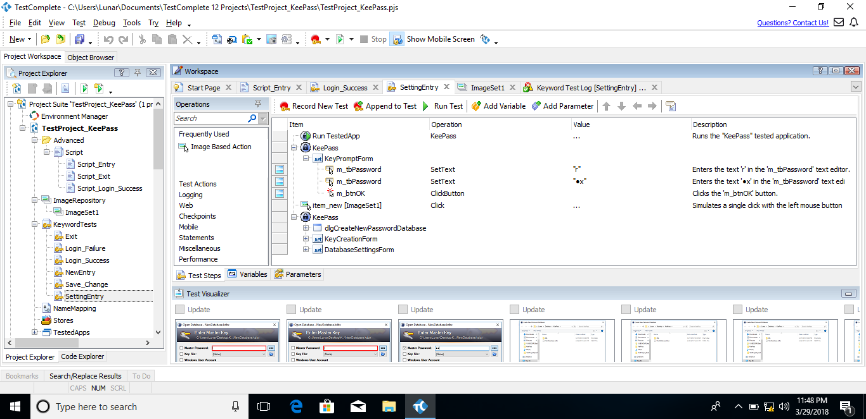To access keyword-driven, simply click the “Record New Test” button for a new test or “Append to Test to continue testing from a point.
* 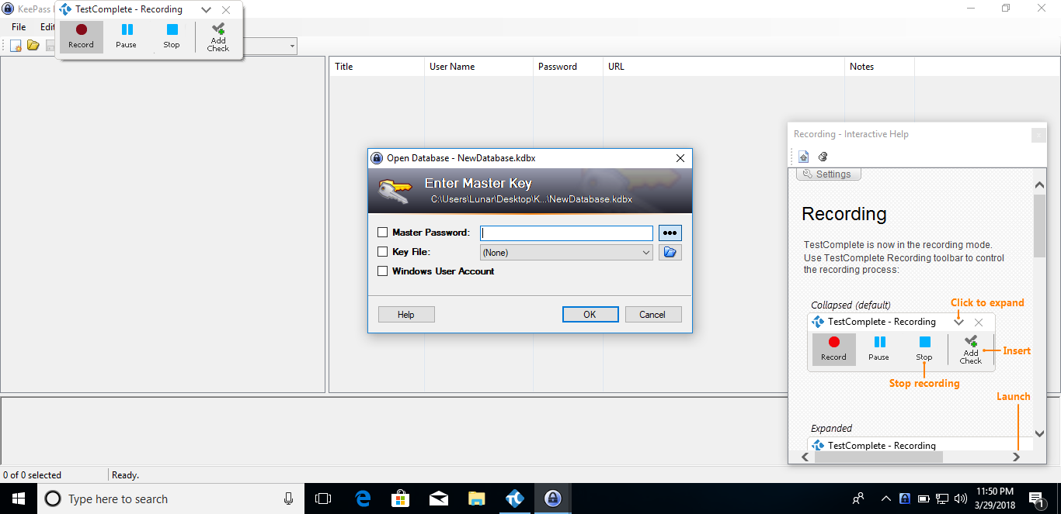After that, there will be a small window for control, in here, we can stop, pause or add a check point to the current test. There will also be a help window to guide you along the way. Simply click “Stop” when you are done.

1. TC001 & TC002 - Login (success/failure)

* Success: by entering the password ‘rx’

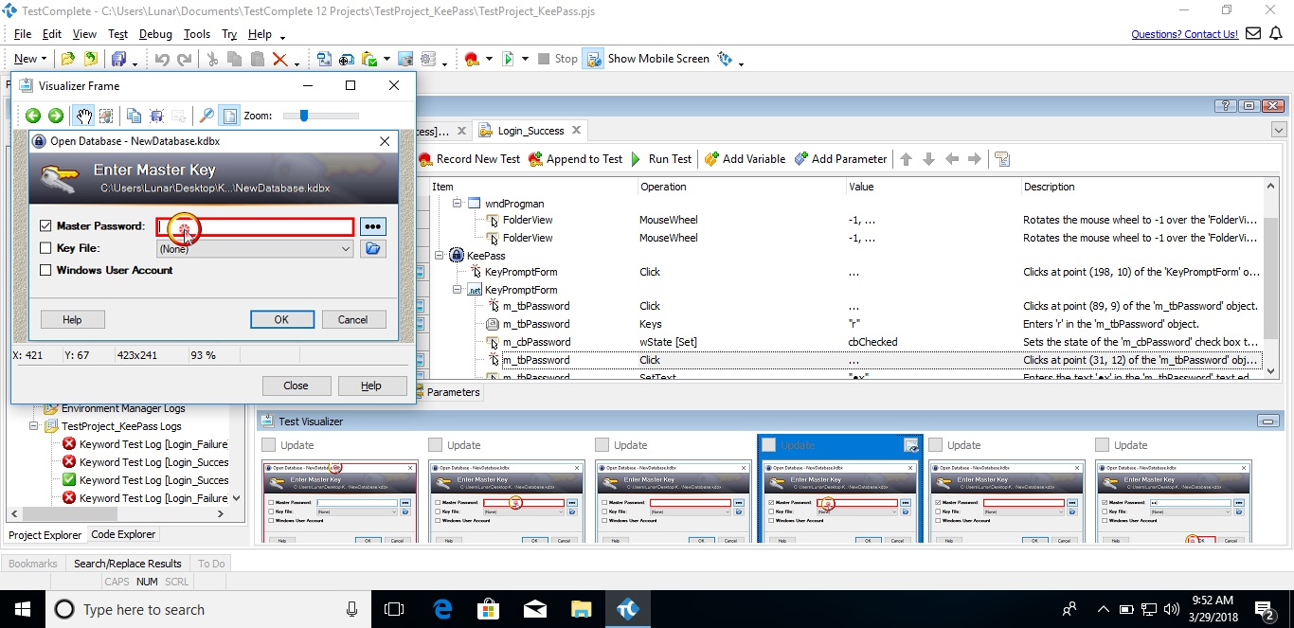

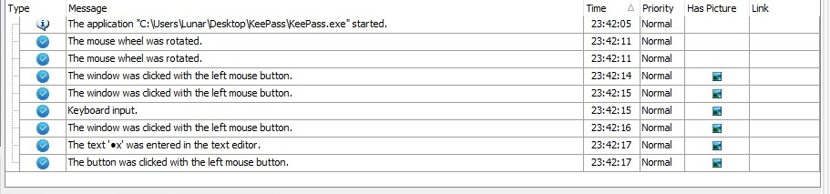

* Failure: use a set of incorrect passwords to check out -> unable to login. You can try another set of passwords by modify the data file (data.csv). As this is also related to data-driven testing, it will be address later below.

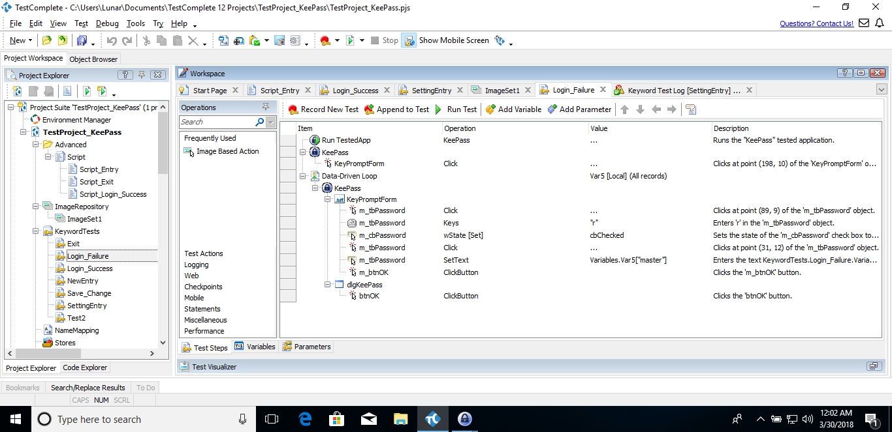

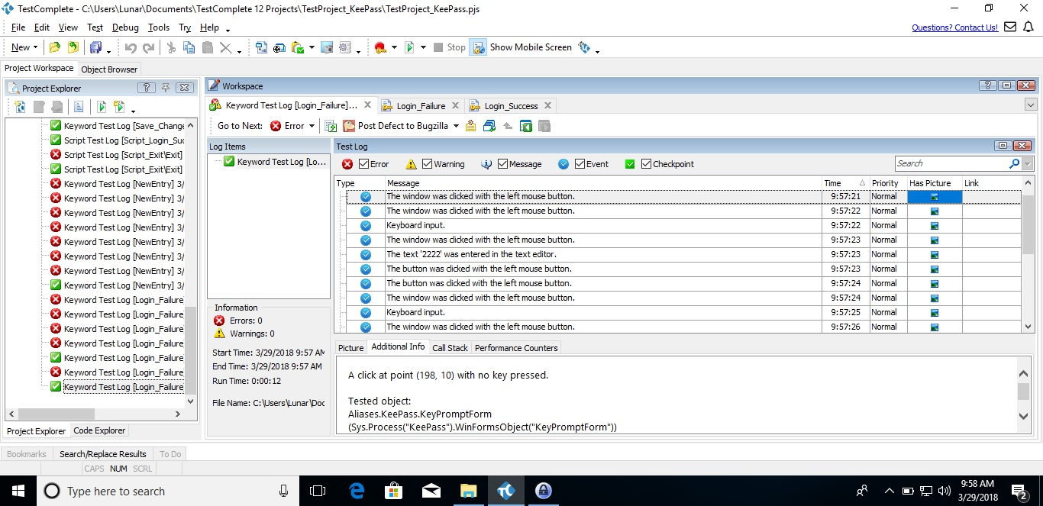

1. TC003 - Save Changes

In here, we create a new database and save it (in order to run this test the second time, please delete the database in the original folder and replace the ‘KeePass.config’ file’s data with the one from ‘KeePass-Original.config’ or you can change the name variable and password to the new database’s so they won’t overlap).

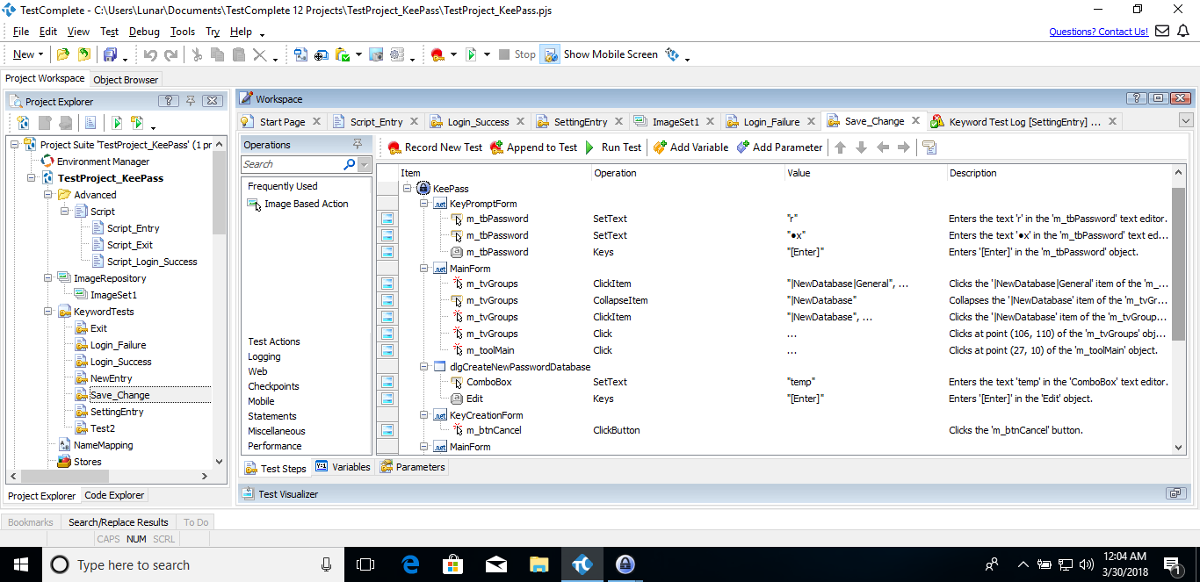

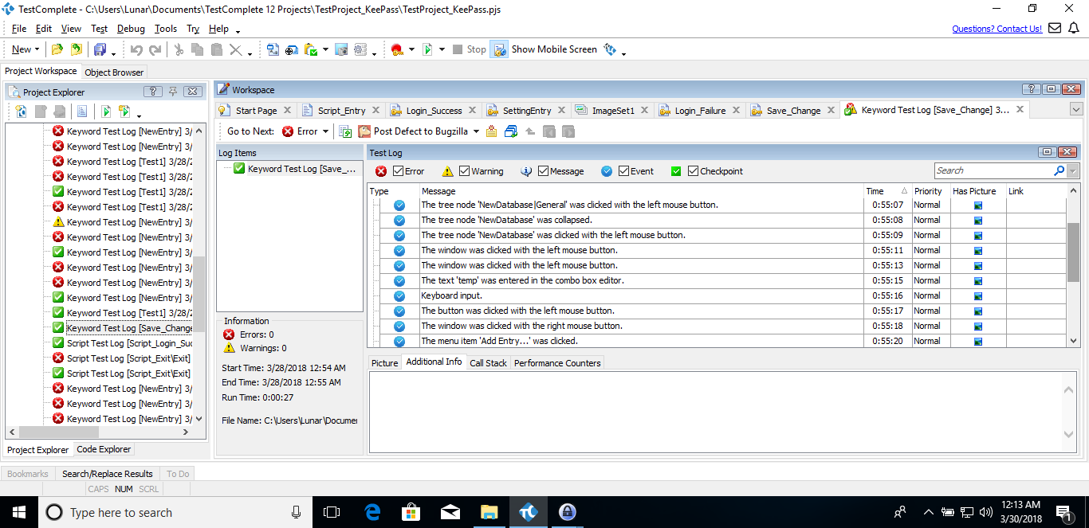

1. TC004 - Create a new database and new entry

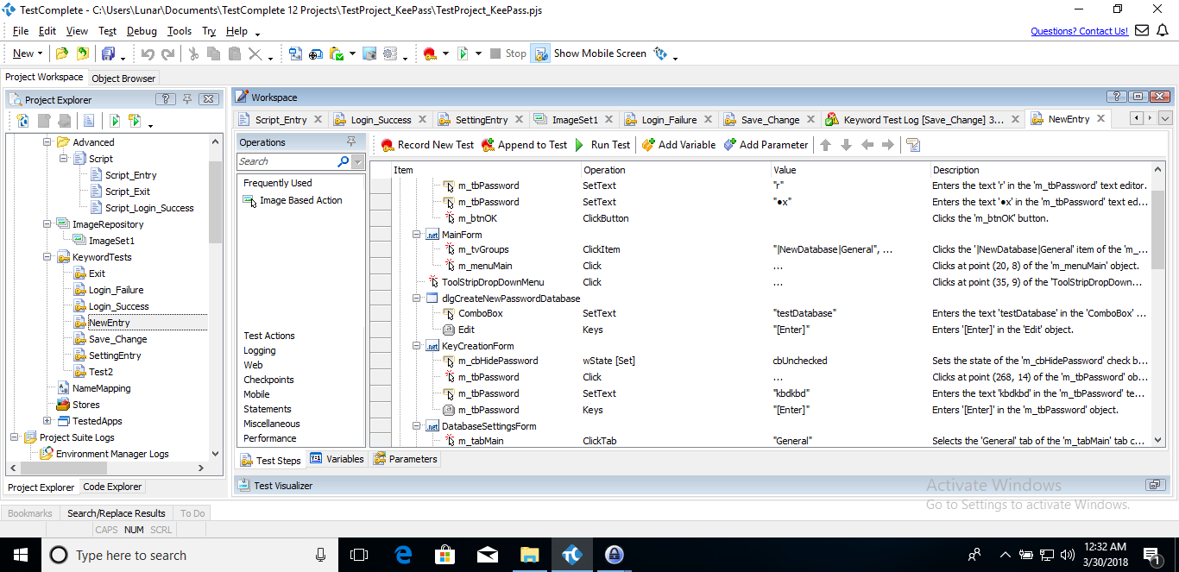

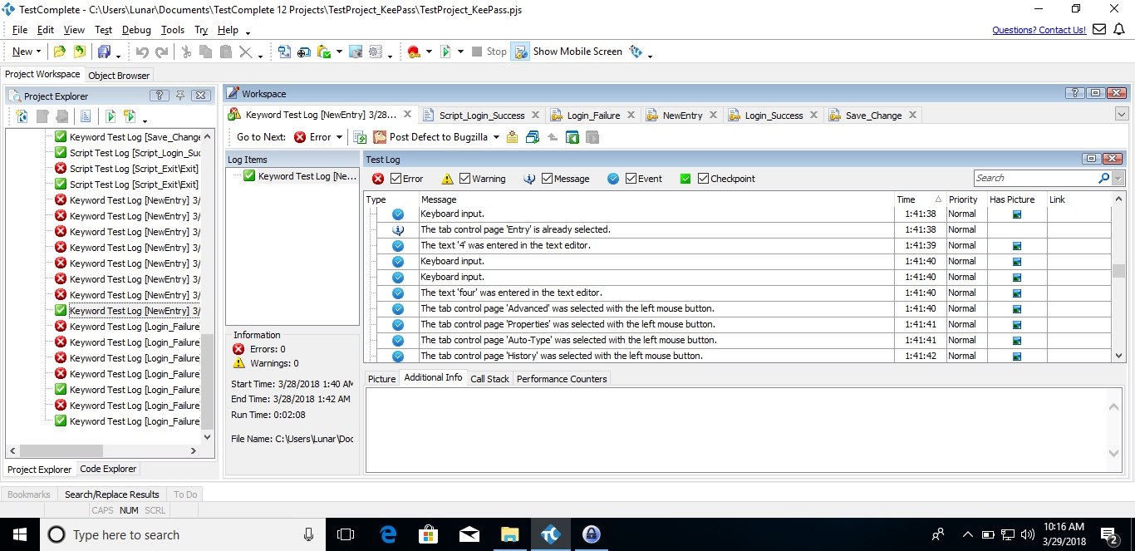

1. TC005 - Exit the application

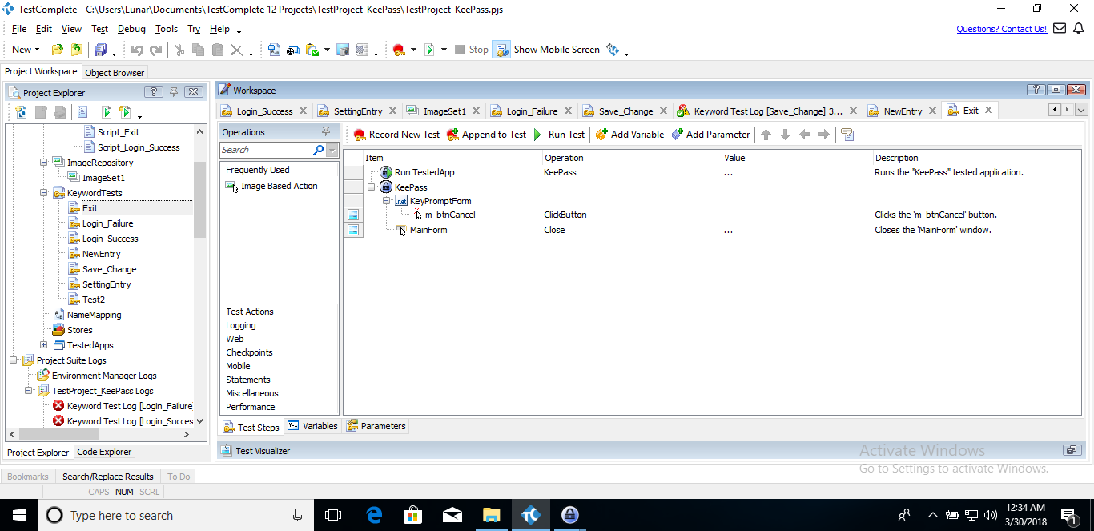

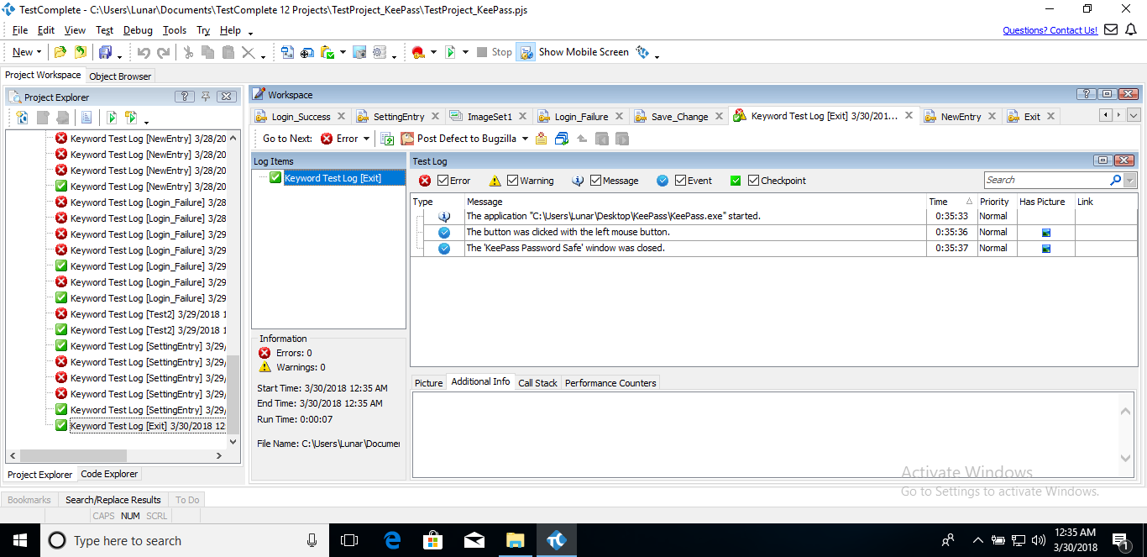

**II – Data-Driven Testing:**

* 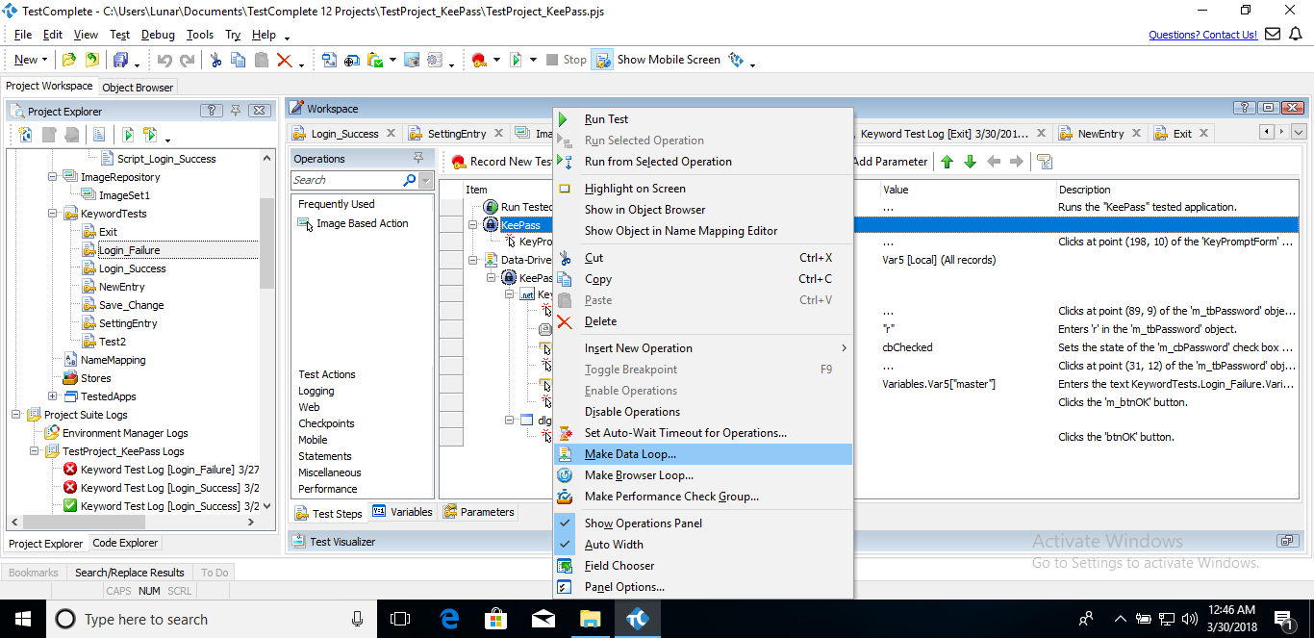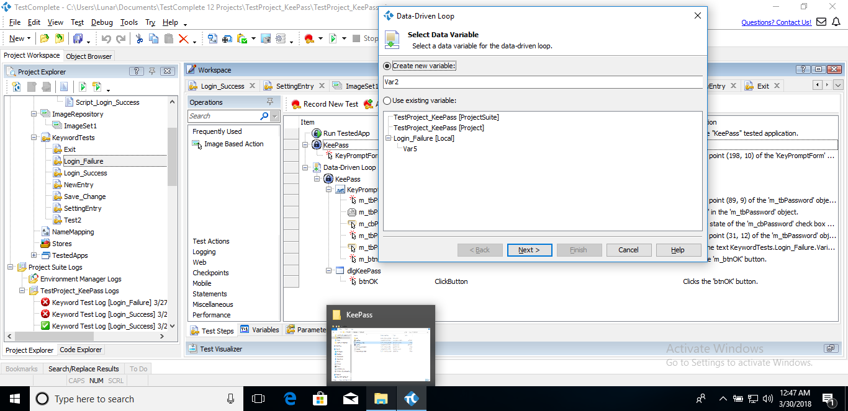In Test Complete, to do data-driven testing, you need to prepare a set of data (Excel Worksheet, CSV file, Database table, Database Query or Table variable, detail are described later as you follow the step). Then select a list of action that you want to repeat with different set of data, then right click and select “Make Data Loop”, then create a new variable or choose 1 you made beforehand, set a name and finally click finish.

The data file we will be using here is a .csv file. To view more information about this process, please visit this link: <https://support.smartbear.com/testcomplete/docs/testing-with/data-driven/index.html>

1. TC006 - Load username and title when create a new entry

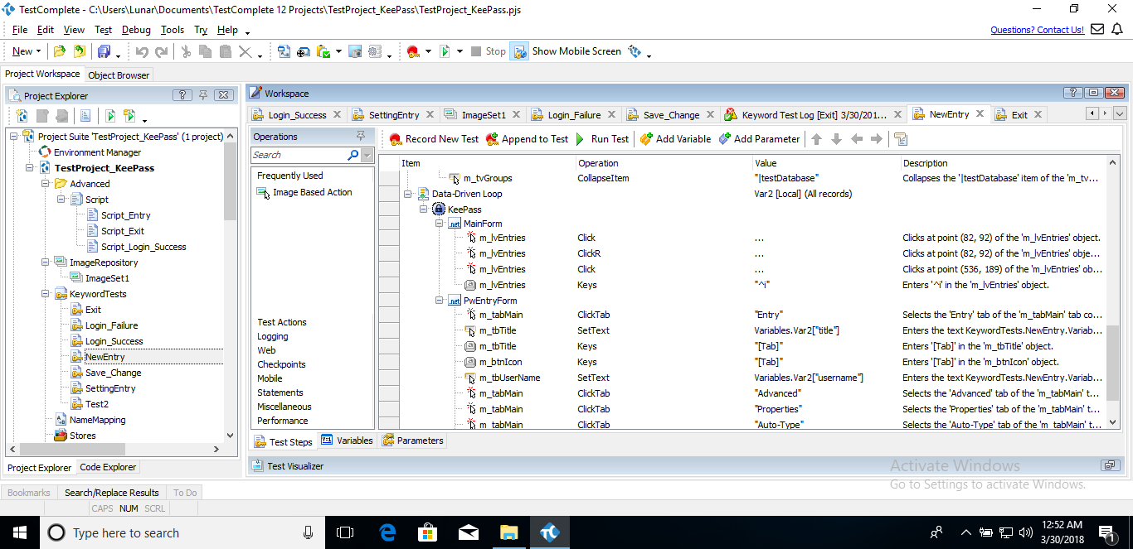

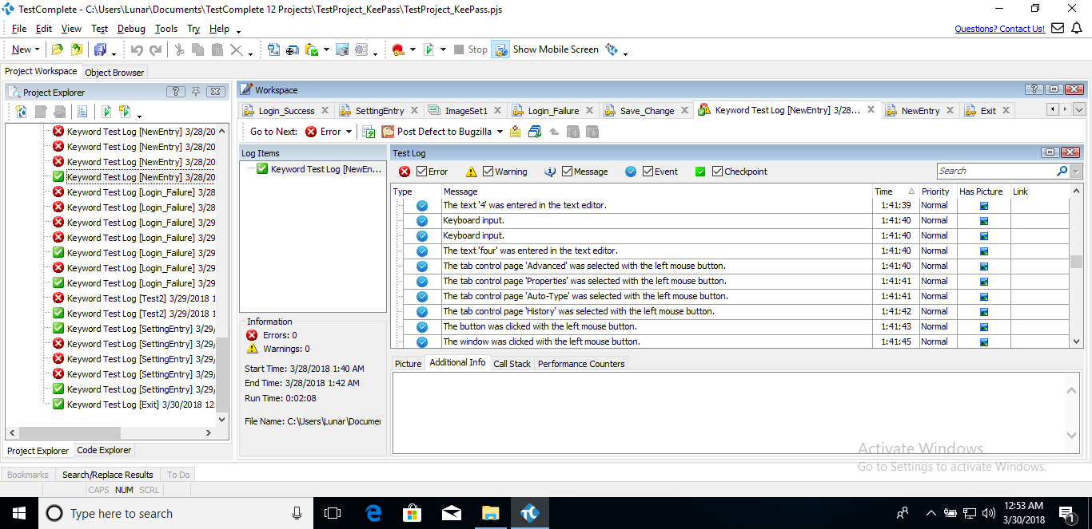

* Picture above described the process working on the 4th variable,

1. TC007 - Check password when login

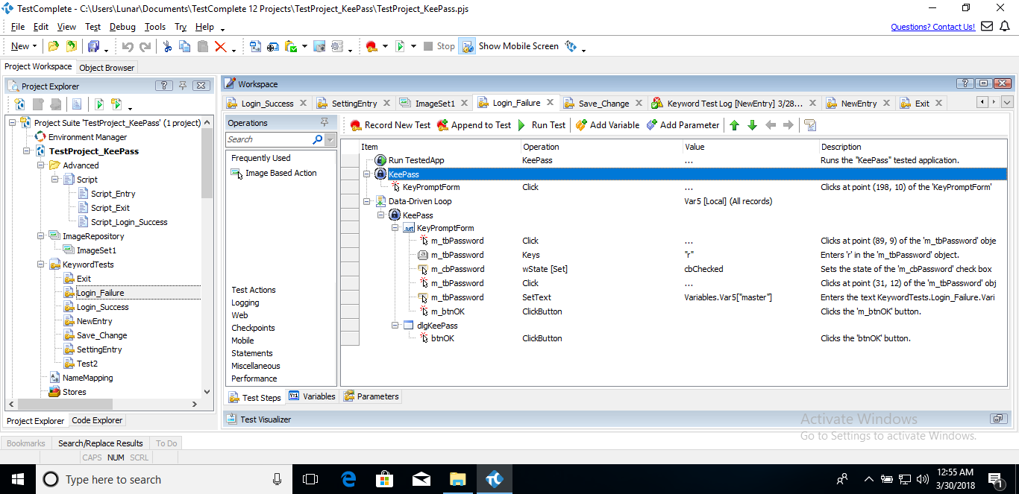

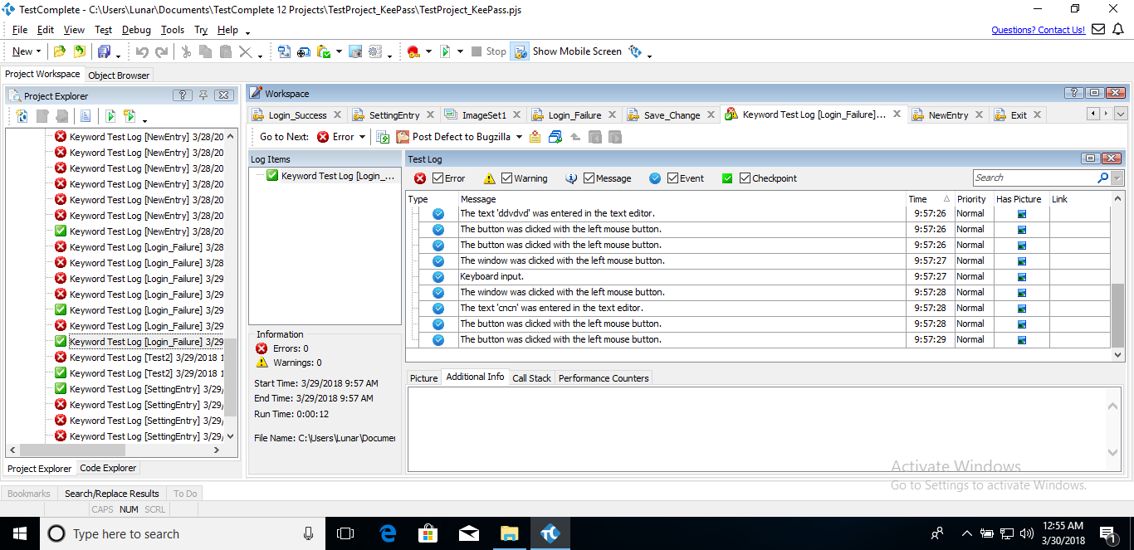

* Picture above is the recreation of “TC002 – Login (Failure)” by making a set of wrong passwords. You can change 1 of the data to the right one and there will be an error to notify user.

**III – Script Testing:**

There are 2 ways to do this kind of testing in Test Complete, either create a completely new script or record a keyword-driven test and convert it to script. In this case, we will use the second method and reuse some of the above keyword-driven test cases above for this. In order to this, simply right click the test you want to convert and click “Convert to Script”, then follow the next menu as instructed. Here you can either turn it into a new script test or one you already made beforehand. In this case, we user ‘Python’ language for the script. For more information, please visit this link: <https://support.smartbear.com/testcomplete/docs/scripting/index.html>

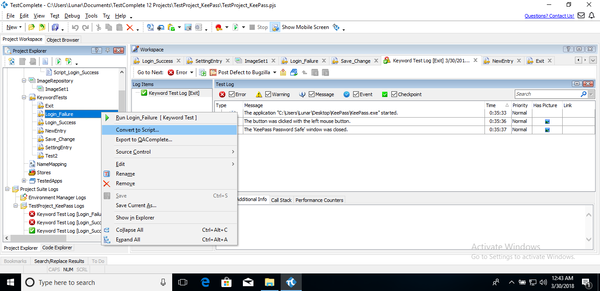 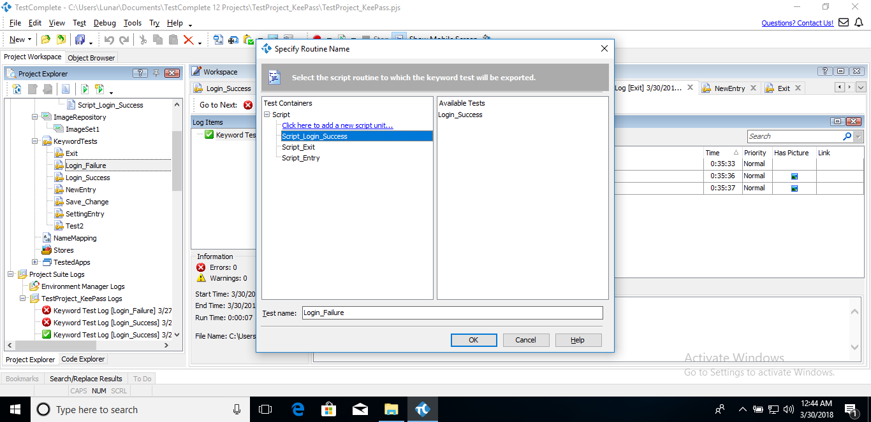

1. TC008 - Login from app

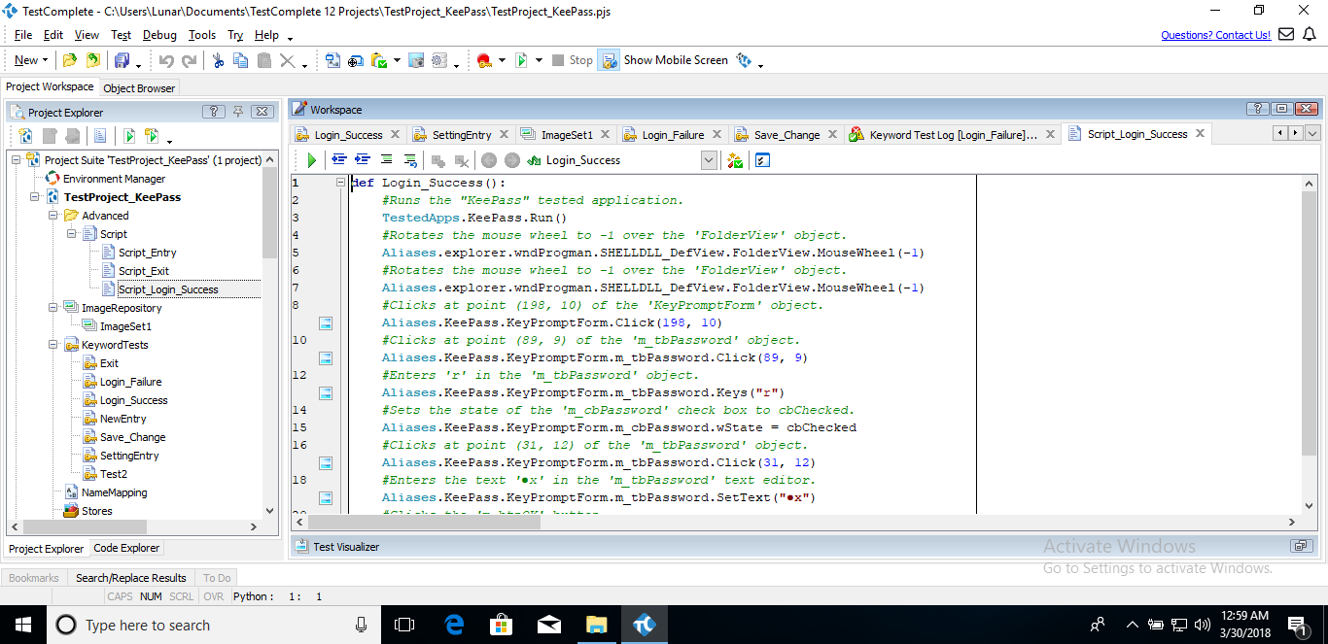

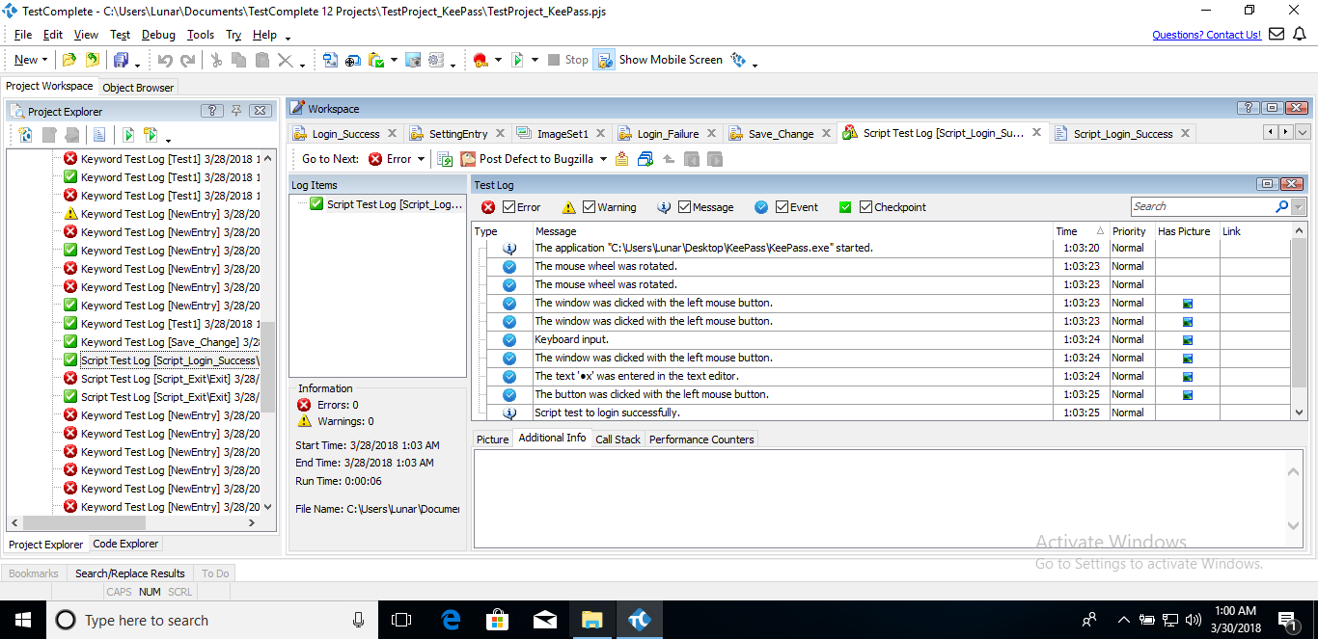

1. TC009 - Exit the application

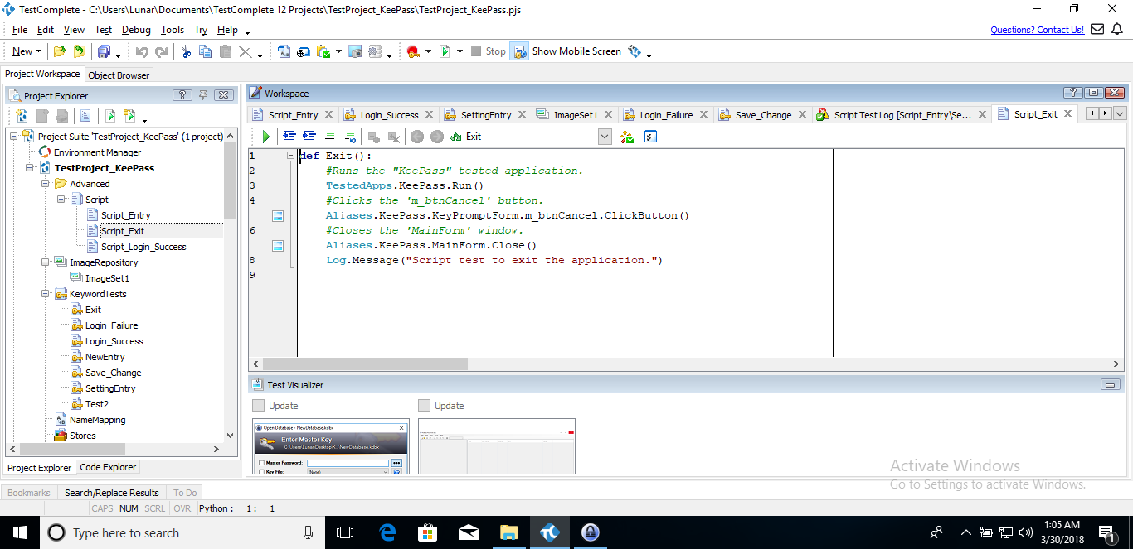

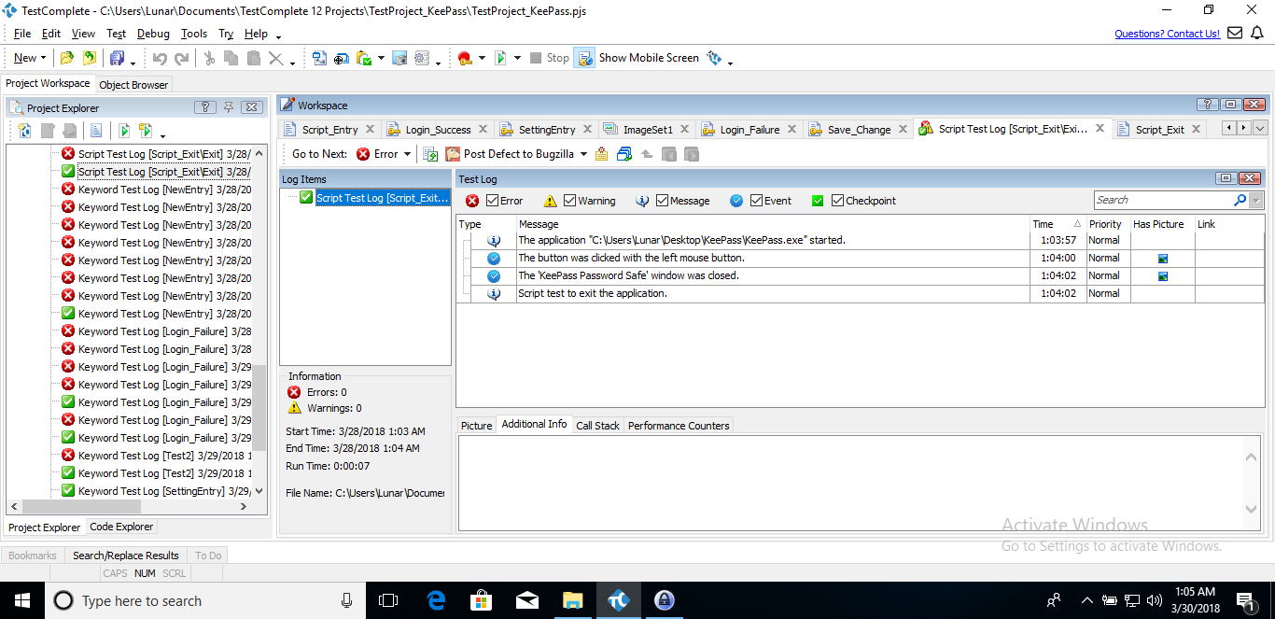

1. TC010 – Make a new entry

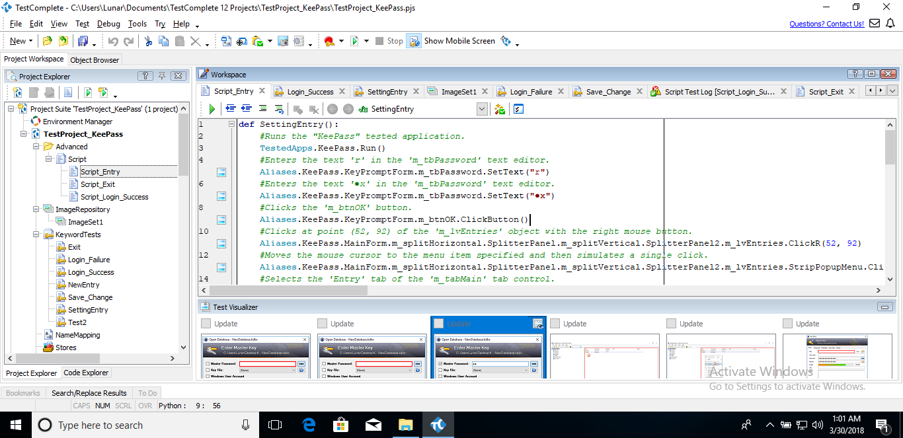

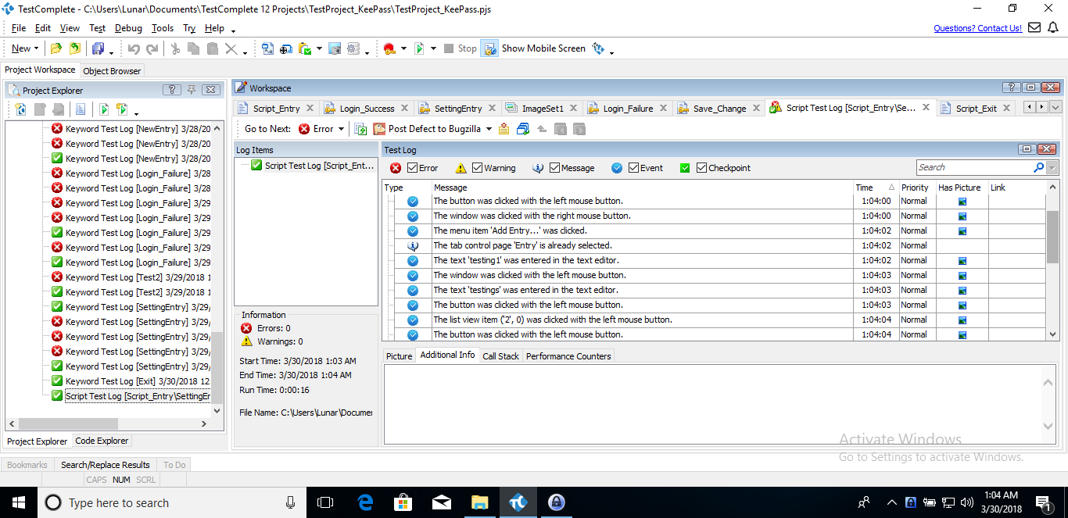

**IV – Image-based Testing:**

* In Test Complete, to do Image-based testing, you need to prepare an image before hand so that the tool can compare your image with what is present on the screen and work with that image. To do this, first, right-click your project and select “Add” 🡪 “New item”. Then select “ImageRepository” 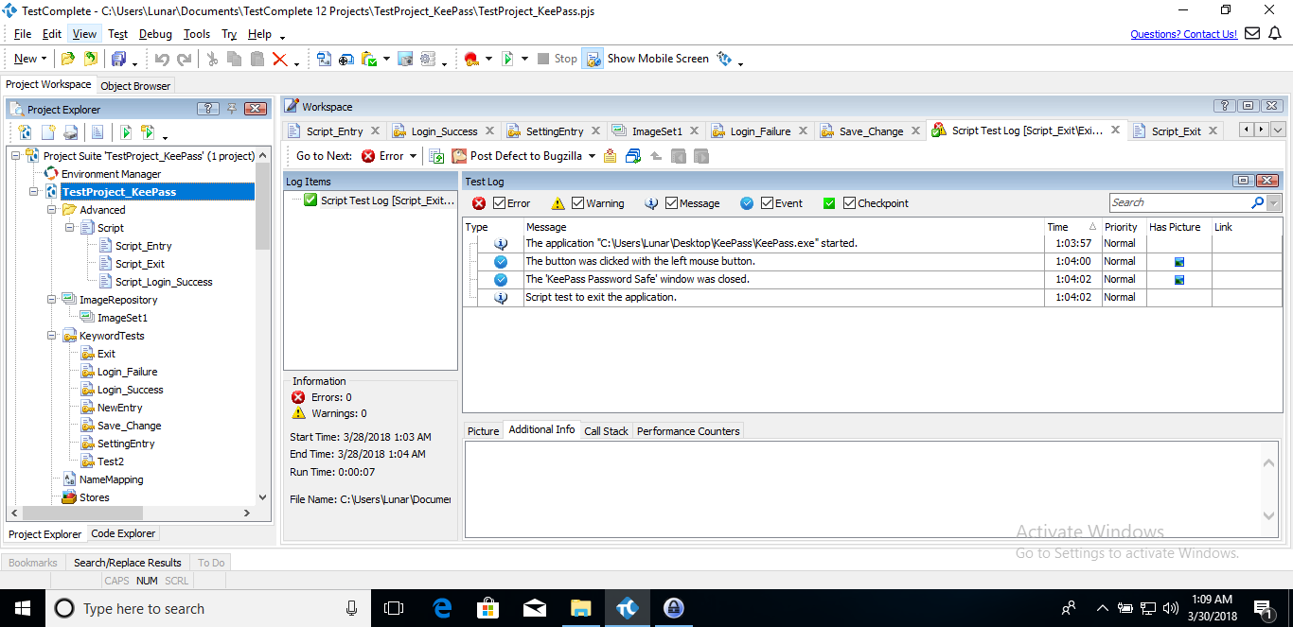. After that, right click it and select “Add” 🡪 “New item”, then select “Image Set”, name it and click OK.

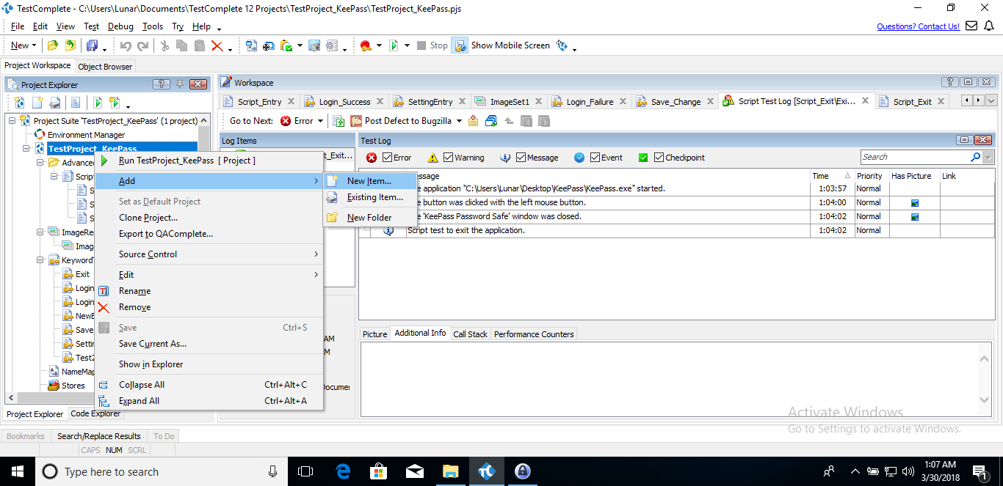 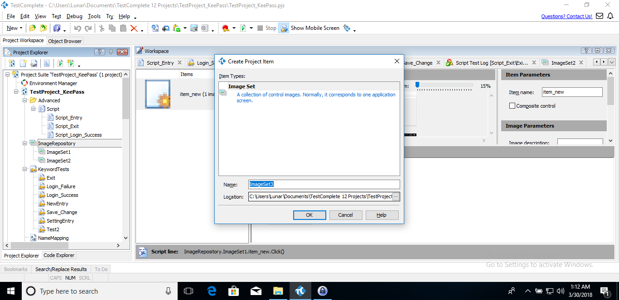

* You will then be greeted with the screen below. Right-click the blank space in ‘Item’, right click and select “Add item”. You will then be able to crop your CURRENT desktop screen to select the image you want to use or load an image from somewhere (not recommend), click OK to finish.

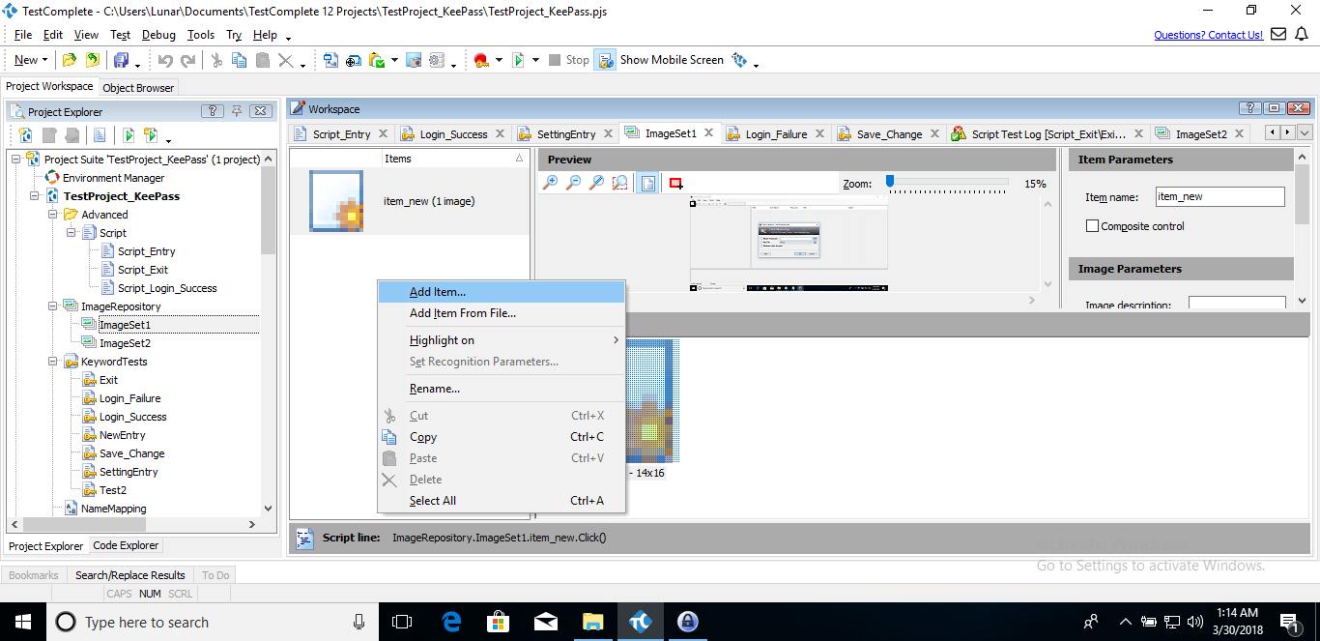

* Finally, go into a keyword test you made, and select “Image Based Action”, select the icon you want to use and follow the instruction on screen.

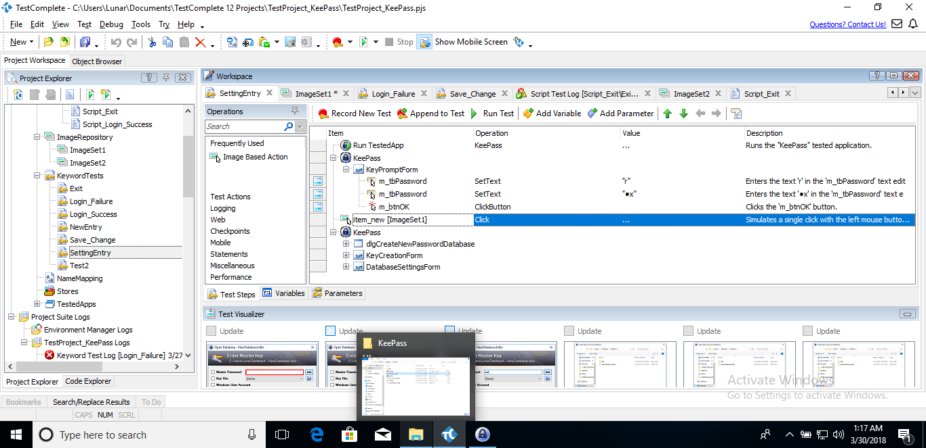

* Select the action you want and set some values (to specify the area of your SUT you want to check for quicker process, don’t change anything if you don’t know what to do here). Click “Finish” when you are done. For more information regarding this kind of testing, please visit this link: <https://support.smartbear.com/testcomplete/docs/app-testing/image-based/tutorial.html>

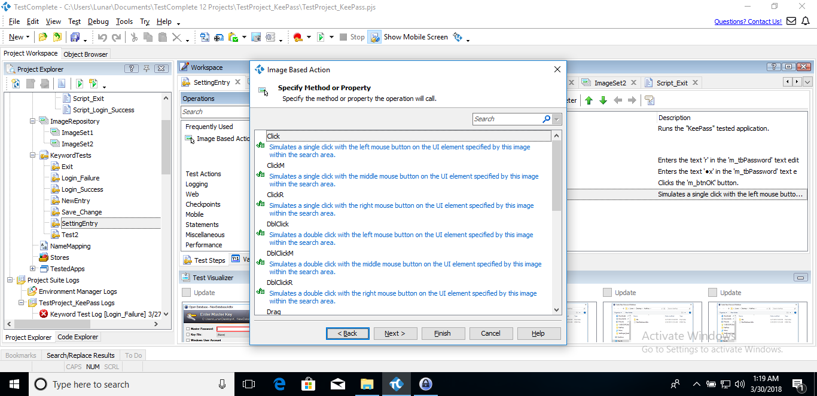 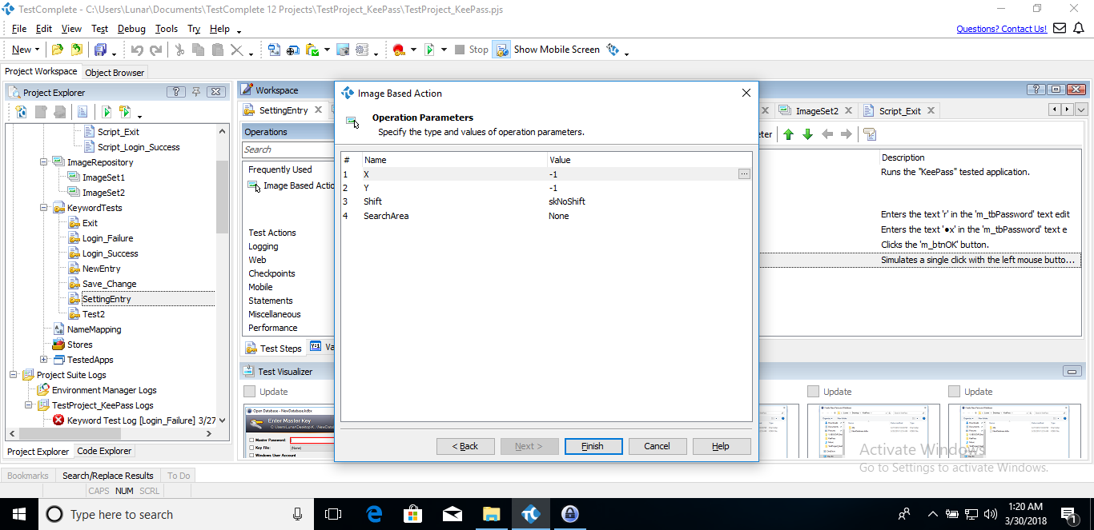

1. TC011 - Create a new database

